- How are angular frequency and amplitude affected by time etc?
- Reading in V-I meters immediately and after long time.
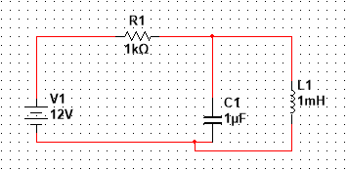

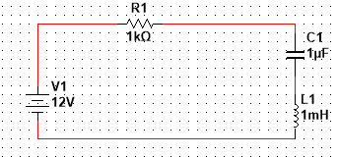
- LR maximum energy, time to reach fraction of maximum, current at time
- LC circuit charge, max energy in capacitor, time etc.

